Getting Started with Animation Combo System:

* Watch the YouTube videos for extra details and information:

https://www.youtube.com/playlist?list=PLTRqRMIx9RtjK9vCxeFFT8qqbtrNGbPx-

Manuel Steps:

- In your script Create a ComboSequencer Object

- Call the Initialise() method in Start()

- Call the Update() method in your Update Loop

- Assign combos and the Animator references in the inspector

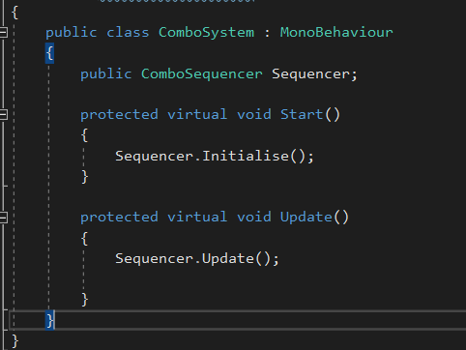- Hit play!

# **Input Sequencer**

Common Traits:

* The EnableTimeLimit checkbox, instructs the sequencer to clear its buffer every X seconds (resetting the key input to 0)
* If the InputSequence list is longer in length than the Attacks list, the Sequencing type will set itself automatically to “Full”
* If the Attacks list is longer than the InputSequence list in length, the last correct Key stroke will chain the remaining Attack Animations together in 1 long sequence

|  |  |  |  |
| --- | --- | --- | --- |
| **Sequencing Type** | **Description** | **Link Begin Function** | **Link End Function** |
| **Full Sequencer** | Player must input the full Key Sequence before triggering the combo and its Animations | The time at which we link/transition to the next animation in the combo chain | Does not have an effect |
| **Partial Sequencer** | * First correct key stroke triggers the first Animation in the sequence * Onwards: every correct key stroke within the LinkBegin and LinkEnd time span of the animation triggers the next Animation in the chain * Keystrokes (correct or false) that aren’t within that timespan are completely ignored | The point at which we start listening for input strokes | The point at which we stop listing for input strokes |
| **Partial Appending Sequencer** | With every Keystroke (correct or false) a command is put into a buffer (no waiting times).  The Scheduler will execute the next command in queue accordingly | No effect | The time at which we link/transition to the next animation in the combo chain |

**Events:** you could subscribe to the Dispatcher’s Events (Dispatcher.cs) to extend and create custom logic

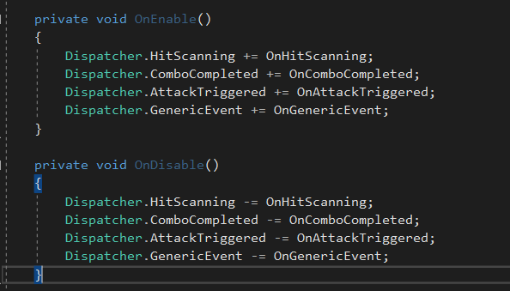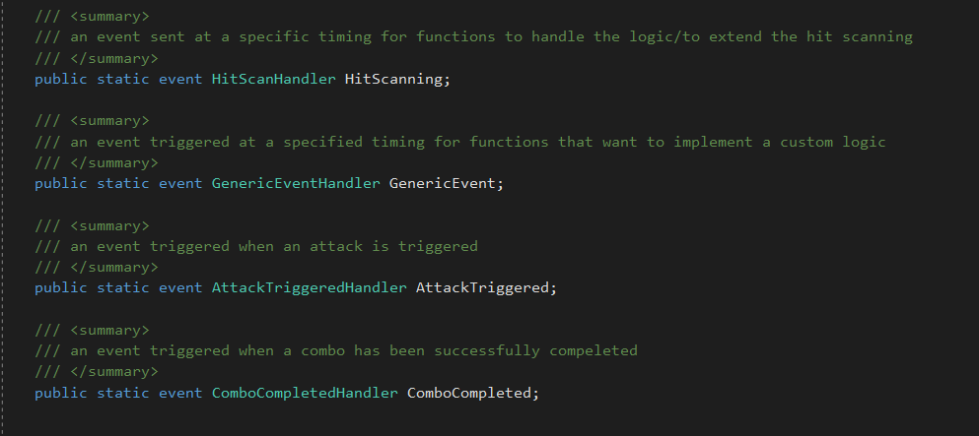list of the current Events: